10-19-23 notes

Working with Weather and City APIs

Goals:

By the end of this lesson, you will be able to:

* Create applications with your knowledge of Python and an API’s documentation.
* Load JSON from API responses into a Pandas DataFrame.
* Use try-except blocks to handle errors.

**JSON transversal solution:**

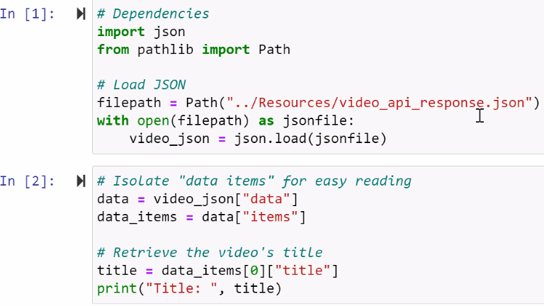

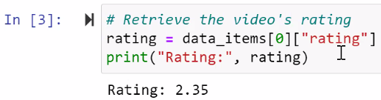

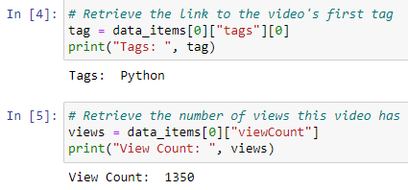

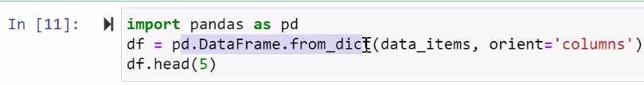

^ Put JSON into a data frame (it’s pulling from the dictionary we stuck the JSON in during In[2] ).

**Requests Review Solution:**

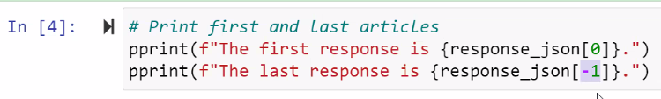

-1 loops back to grab the last response.

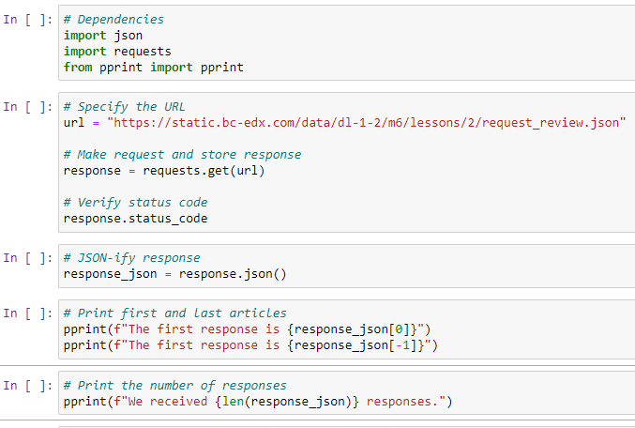

**Instructor Open Weather Request Solution:**

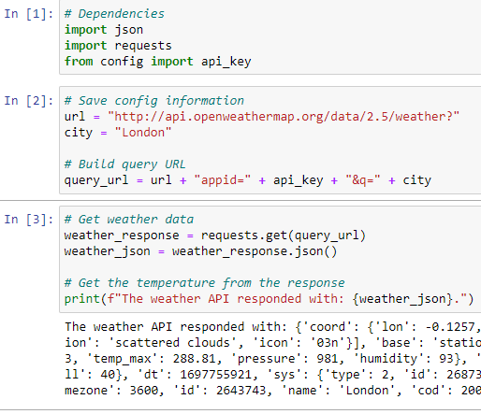

^ Question mark? in URL tells server to interpret next chunk as key value pair, separated by &

* Get and post method
  + Basically a digital envelope with the request inside. It’s a security thing

**Burundi Solution:**

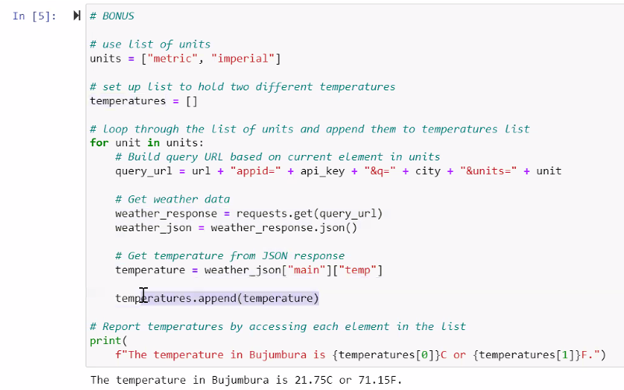

**TV ratings solution:**

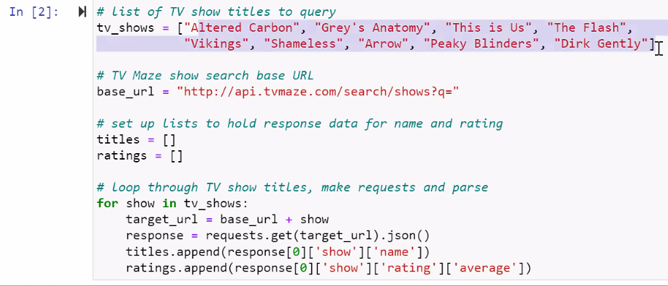

**Weather Stats solution:**

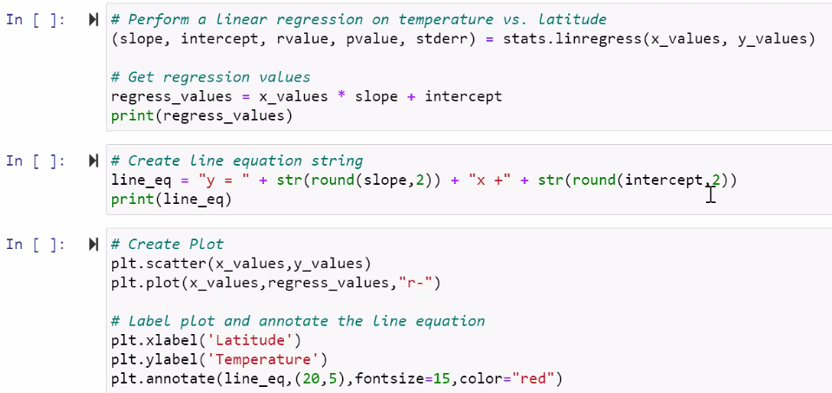

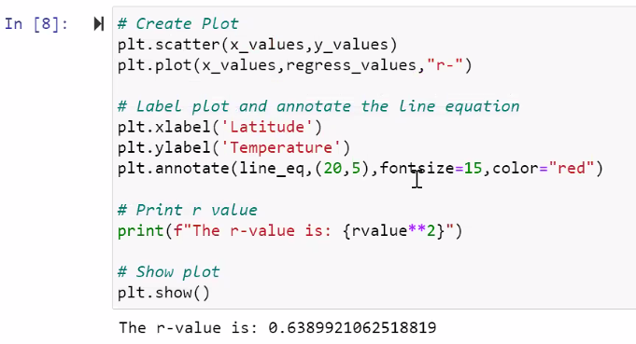

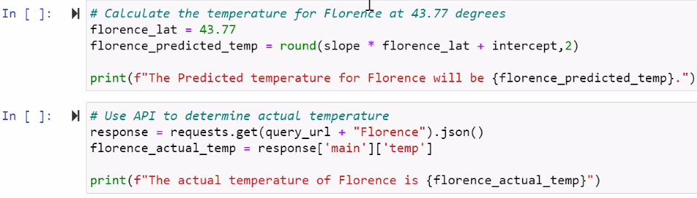

**Exceptions**

When you have a bit of code that throws an error, you can build in a step to have it tell you there’s an error.

Example:

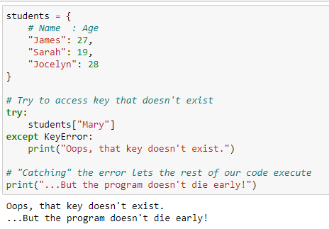

**Making Exceptions solution:**

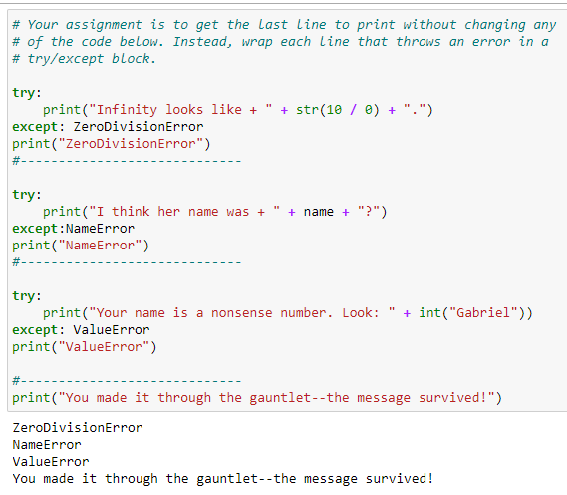

Of you can tell it to print off something reasonable, like “You can’t divide by 0”, “You didn’t define Name”, or “Gabriel isn’t a number”

**API Exceptions Solution:**

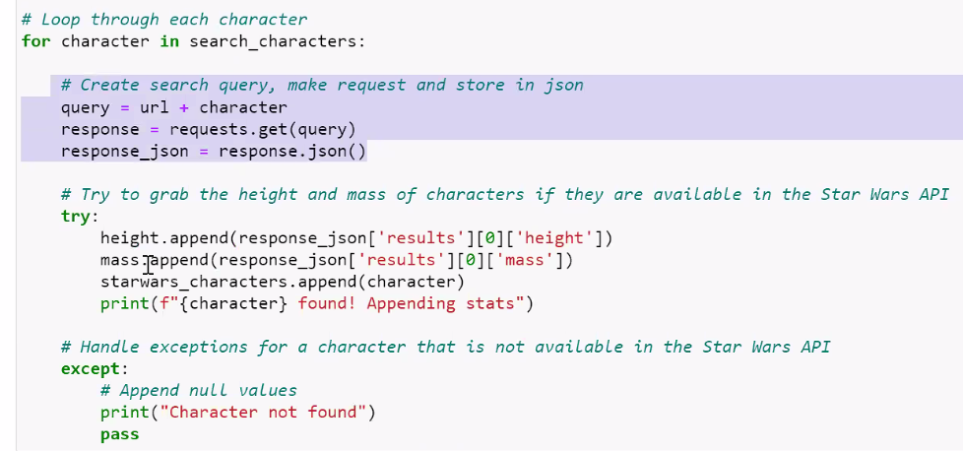

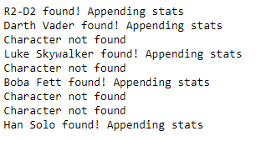

Exceptions are applied here so you can know which characters weren’t found.

Only characters that were found will be put into the dataframe in the next step.

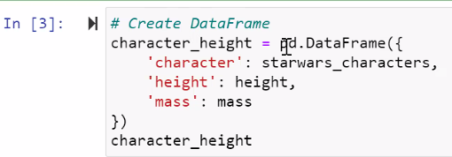

^ This didn’t want to work for me. Review 9:06pm in recording to sort this out.

**World Bank solution:**

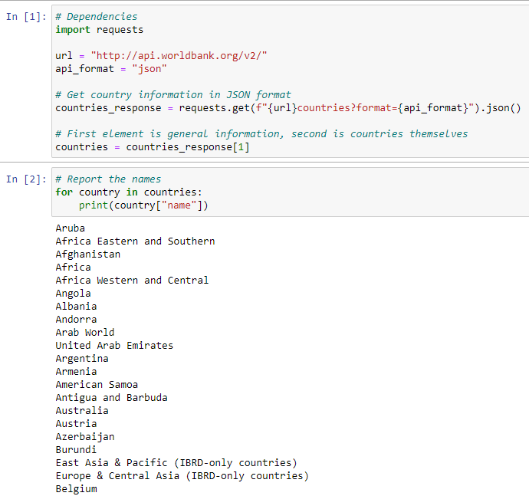

You can pass the format JSON to get the results back as a json

^9:13pm in recording

**Two calls solution:**

First call: Gets the countries

Second call: Gets more info

Second calls are common when you’re actually working with APIs at your job.

I keep on getting the error below when I try to run my cell 2.



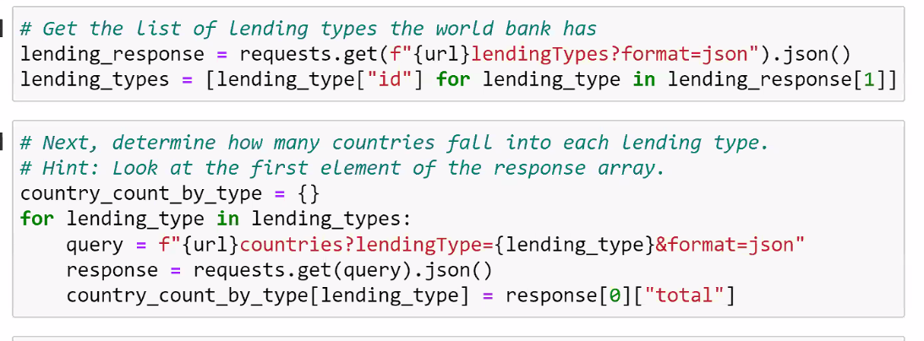

^Manish added a line below response that said **pprint(response)** to see the JSON

^He also added a line in the first cell saying **from pprint import pprint**

In cell above- you’re making a dictionary, with the key [lending type], and the value paired to it [“total”]

